Proceedings template:

Histochemický průkaz hrachové bílkoviny
Histochemical Detection of Pea Protein

Javůrková, Z., Pospiech, M.
Veterinární a farmaceutická univerzita Brno

Souhrn
V masném průmyslu se z důvodu snížení ceny výrobků využívají jako náhrady masa rostlinné bílkoviny, z nichž některé mají alergenní účinek. Proto je v současné době snaha nahradit tyto alergeny jinými rostlinnými bílkoviny, které dle legislativy mezi alergeny nejsou řazeny. Mezi nejčastěji používané patří hrachová bílkovina, která ale také může způsobovat alergické reakce.…….

Abstract
The meat industry uses vegetable proteins as meat substitutes to reduce the price of its products. Some vegetable proteins, however, have allergenic effects. Efforts are therefore being made to replace such allergenic proteins with other vegetable proteins that are not classified as allergens by the legislation. The most commonly used include pea protein, though this may also cause allergic reactions.…….

Key words: Plant proteins, pea flour, microscopy, histochemistry, ………

Introduction
The current consumer’s food choices are influenced by product price. This is one of the reasons why the meat industry uses cheaper raw materials as meat substitutes (Modi et al., 2003). Various protein preparations, e.g. proteins of animal origin (blood plasma, collagen, milk protein) and vegetable origin (soybean, peas), are added to meat products (Kameník et al., 2014). ………

Material and methods
Microscopic specimens were prepared from a pea-flour and protein sample and heat-treated (70 °C, 10 minutes) model samples with a 2.5 % addition of pea flour and protein. Salt (2.5 %) was also added to heat-treated model samples. Model samples were processed in the microscopic laboratory of the Department of Vegetable Foodstuffs Hygiene and Technology according to Standard Operating Procedures and were histochemically stained with haematoxylin-eosin (HE), PAS Calleja (PC) and Toluidine Blue (TB)……

Results and discussion
On the basis of photographs of flour samples (Fig 1–3), characteristic flour structures were demonstrated in model samples with added flour, such as palisade and goblet cells (Fig 4–6), fragments of cotyledon cells with starch granules, and cells containing pea protein as described in the literature (Hohmann, 2007)..……….

Table 1: Numbers of palisade cell fragments in heat-treated model samples with the addition of pea flour and protein per 1 cm²
Stainig | Sample
 | Samples with pea flour | Samples with pea protein
PC | 2.75 ± 1.22 | 0
TM | 1.54 ± 0.83 | 0
HE | 1.50 ± 0.71 | 0

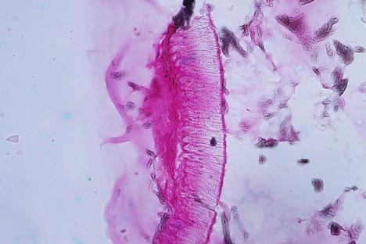
200 µm
Figure 1: palisade cells in pea flour, PC

Conclusion
The results of our study indicate that PAS Calleja staining should be considered the most suitable histochemical staining for the detection of added pea flour as well as pea protein. This kind of staining produces results sufficiently distinguished by colour even for less experienced microscopists. Flour addition can be identified by the detection of palisade and goblet cells, which occurred in all sections, and also by the finding of starch granules…….

References
Czech Republic. Decree no. 113/2005 Coll. of 4th March 2005 on the labeling of foodstuffs and tobacco products. In Sbírka zákonů, 2005, č. 37, s. 1163-1174.
European Union. Regulation of the european parliament and of the council no. 1169/2011 of 25 October 2011,on the provision of food information to consumers, amending Regulations (EC) No 1924/2006 and (EC) No 1925/2006 of the European Parliament and of the Council, and repealing Commission Directive 87/250/EEC, Council Directive 90/496/EEC, Commission Directive 1999/10/EC, Directive 2000/13/EC of the European Parliament and of the Council, Commission Directives 2002/67/EC and 2008/5/EC and Commission Regulation (EC) No 608/2004. In: Úřední věstník Evropské unie L 304, 22/11/2011, s. 18-63.
Hohmann, B. Microscopic examination of herbal food and feed: The Gassner. Hamburg: B.Behr´s Verlag GmbH & Co. KG, 2007. ISBN 987-389947-256-1.

Acknowledgements
This study was supported by the project IGA 228/2015/FVHE of the University of Veterinary and Pharmaceutical Sciences Brno.

Contact address: Mgr. Zdeňka Javůrková, Ph.D., University of Veterinary and Pharmaceutical Sciences Brno, Faculty of Veterinary Hygiene and Ecology, Department of Plant Origin Foodstuffs Hygiene and Technology, Palackého tř. 1946/1, 612 42 Brno, Czech Republic, E-mail: javurkovaz@vfu.cz

